Business Plan

NAME OF BUSINESS

Street Address
City, ST 87654

Ted Black  President  12345 Somewhere Street  Some City, AB 87654  Phone: (123) 456-7890  Fax: (123) 456-7890  Email: name@domain.com | Sue Black  President  12345 Somewhere Street  Some City, AB 87654  Phone: (123) 456-7890  Fax: (123) 456-7890  Email: name@domain.com

Table of Contents

1 Executive Summary 3
1.1 The Quick Pitch 3
1.2 The Problem 3
1.3 The Solution 3
1.4 Highlights 3
1.5 Keys to Success 3
2 Our Team & Organization 4
2.1 Mission Statement 4
2.2 Management & Team 4
2.3 Company Goals and Objectives 4
3 Products & Services 5
4 Market Analysis 6
4.1 Market Summary 6
4.2 Customers 6
4.3 Competition 7
5 Strategy & Implementation 8
5.1 Milestones (Keys to Success) 8
5.2 Customer Acquisition 8
5.3 Pricing Strategy and Revenue Model 9
6 Financial Plan & Projections 10
6.1 Start-up Expenses & Funding 10
6.2 Sales Forecast 11
6.3 3-Year Sales Forecast 12
6.4 Profit and Loss Projection 13
6.5 Balance Sheet 14
6.6 3-Year Cash Flow 15
6.7 Business Budget 16
6.8 Break-Even Analysis 17

Executive Summary

The Quick Pitch
[In one sentence... what does our company do?]
[Tip: Being able to describe what your business does in just once sentence will be a huge asset to you as you talk about it with others. Work on refining your quick pitch again after completing your business plan.]

The Problem
[What problem are you solving for the consumer?]

[How big is the problem?]

[Are there currently any solutions out there?]

The Solution
[How does your business solve the problem?]

[Is it a simple solution or a complex solution?]
[Tip: If it is complex, how can you make it simple, or describe it more simply?]

Highlights
[Type content here]

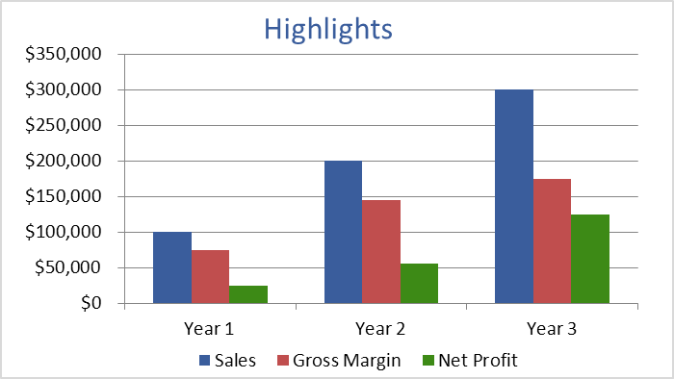
[Optional caption for graph]

Keys to Success
[What are the main steps you'll need to take to be successful (3-6 steps)?]

Our Team & Organization

Vision Statement
[This vision statement should be related to your team and organization]

Mission Statement
[This mission statement should be related to your team and organization]

Management & Team
[Who is working on this with you?]

[What are your backgrounds?]

[What industry experience do they have?]

[What makes your team qualified to make your business a success?]

[Who do you need to hire?]

Professional and Advisory Support
Board of Directors | [names]
Management Advisory Board
Attorney
Accountant
Insurance Agent
Banker
Consultant(s)
Mentors and Key Advisors

Company Goals and Objectives
[Type content here]

Products & Services

[Type content here]

Market Analysis

Market Summary
[How big is the market for your business & how much demand is there?]

Customers
[Describe your target audience.]

[How much will your target audience pay for your product/service?]

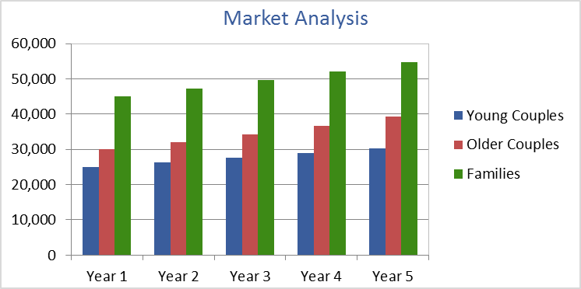
[Optional caption]

Competition
[How much competition is out there?]

[Who are your competitors and what are their strengths and weaknesses?]

[How is your business and solution better than theirs?]

FACTOR | Me | Strength | Weakness | Competitor A | Competitor B | Importance to Customer
Products
Price
Quality
Selection
Service
Reliability
Stability
Expertise
Reputation
Location
Appearance
Sales Method
Credit Policies
Advertising
Image

Strategy & Implementation

Customer Acquisition
[How will you gain customers?]

[How much money will it take to gain them?]

[What will your Customer Lifetime Value be?]

Pricing Strategy and Revenue Model
[What will your pricing strategy be?]
[What is your revenue model?]

Financial Plan & Projections

Start-up Expenses & Funding
[Briefly summarize the start-up expenses and sources for funding and explain any anomalies shown in the tables. Customize the expense and funding tables in the business plan companion spreadsheet then copy and paste them below.]

Start-up Expenses
Fixed Costs
 | Legal and Permits | $5,000
 | Stationery and Supplies | $3,000
 | Insurance | $10,000
 | Rent | $2,000
 | Office Equipment | $5,000
 | Website Development | $5,000
 | Print Advertisements | $10,000
 | Brochures | $5,000
 | Total Fixed Costs | $45,000
Average Monthly Costs
 | Rent | $2,000
 | Utilities | $5,000
 | Salaries / Wages | $5,000
 | Total Average Monthly Costs | $12,000
 | x Number of Months: | $6
 | Total Monthly Costs | $72,000
Total Startup Expenses |  | $117,000

Start-up Assets
Owner Funding
 | Owner 1 Cash | $50,000
 | Owner 2 Cash | $50,000
 | Other
 | Total Owner Funding | $100,000
Loans
 | Bank Loan 1 | $0
 | Bank Loan 2 | $0
 | Other
 | Total Loans | $0
Other
 | Grant 1 | $0
 | Grant 2 | $0
 | Other
 | Total Other Funding | $0
Total Start-up Assets |  | $100,000

Profit and Loss Projection
[See the profit and loss worksheet in the companion Excel workbook]
INCOME | 2012 | % of OI |  | 2013 | % of OI |  | 2014 | % of OI
Operating Income
Category 1 |  | - |  |  | - |  |  | -
Category 2 |  | - |  |  | - |  |  | -
Category 3 |  | - |  |  | - |  |  | -
Category 4 |  | - |  |  | - |  |  | -
Total Operating Income (OI) | $0 | - |  | $0 | - |  | $0 | -
Non-Operating Income
Interest Income
Rental Income
Gifts Received
Donations
Total Non-Operating Income | $0 |  |  | $0 |  |  | $0
Total INCOME | $0 | - |  | $0 | - |  | $0 | -
EXPENSES
Operating Expenses
Accounting and Legal |  | - |  |  | - |  |  | -
Advertising |  | - |  |  | - |  |  | -
Depreciation |  | - |  |  | - |  |  | -
Dues and Subscriptions |  | - |  |  | - |  |  | -
Insurance |  | - |  |  | - |  |  | -
Interest Expense |  | - |  |  | - |  |  | -
Maintenance and Repairs |  | - |  |  | - |  |  | -
Office Supplies |  | - |  |  | - |  |  | -
Payroll Expenses |  | - |  |  | - |  |  | -
Postage |  | - |  |  | - |  |  | -
Rent |  | - |  |  | - |  |  | -
Research and Development |  | - |  |  | - |  |  | -
Salaries and Wages |  | - |  |  | - |  |  | -
Taxes and Licenses |  | - |  |  | - |  |  | -
Telephone |  | - |  |  | - |  |  | -
Travel |  | - |  |  | - |  |  | -
Utilities |  | - |  |  | - |  |  | -
Web Hosting and Domains |  | - |  |  | - |  |  | -
Total Operating Expenses | $0 | - |  | $0 | - |  | $0 | -
Non-Recurring Expenses
Furniture, Equipment & Software |  | - |  |  | - |  |  | -
Gifts Given |  | - |  |  | - |  |  | -
Total Non-Recurring Expenses | $0 | - |  | $0 | - |  | $0 | -
Total EXPENSES | $0 | - |  | $0 | - |  | $0 | -
Net Income Before Taxes | $0 |  |  | $0 |  |  | $0
Income Tax Expense
NET INCOME | $0 |  |  | $0 |  |  | $0
Owner Distributions / Dividends
Adjustment to Retained Earnings | $0 |  |  | $0 |  |  | $0

Balance Sheet
[See the balance sheet worksheet in the companion Excel workbook]
Assets | 2017 | 2016
Current Assets
Cash | $11,874
Accounts receivable
Inventory
Prepaid expenses
Short-term investments
Total current assets | $11,874 | $0
Fixed (Long-Term) Assets
Long-term investments | $1,208
Property, plant, and equipment | $15,340
(Less accumulated depreciation) | -$2,200
Intangible assets
Total fixed assets | $14,348 | $0
Other Assets
Deferred income tax
Other
Total Other Assets | $0 | $0
Total Assets | $26,222 | $0
Liabilities and Owner's Equity
Current Liabilities
Accounts payable | $8,060
Short-term loans
Income taxes payable | $3,145
Accrued salaries and wages
Unearned revenue
Current portion of long-term debt
Total current liabilities | $11,205 | $0
Long-Term Liabilities
Long-term debt | $3,450
Deferred income tax
Total long-term liabilities | $3,450 | $0
Owner's Equity
Owner's investment | $7,178
Retained earnings | $4,389
Total owner's equity | $11,567 | $0
Total Liabilities and Owner's Equity | $26,222 | $0
 |  | {42}
Common Financial Ratios
Debt Ratio (Total Liabilities / Total Assets) | 0.56
Current Ratio (Current Assets / Current Liabilities) | 1.06
Working Capital (Current Assets - Current Liabilities) | 669 | -
Assets-to-Equity Ratio (Total Assets / Owner's Equity) | 2.27
Debt-to-Equity Ratio (Total Liabilities / Owner's Equity) | 1.27

3-Year Cash Flow
[See the cash flow worksheet in the companion Excel workbook]

CASH BALANCE |  | 2015 | 2016 | 2017
 | Date Ending | 9/3/2015 | 9/3/2016 | 9/3/2017
 | Cash at Beginning of Period | $5,000 | $5,000 | $5,000
 | Cash at End of Period | $5,000 | $5,000 | $5,000
CASH INFLOWS |  | 2015 | 2016 | 2017
Cash from Operations
 | Receipts from Customers
 | Gross Rents
 | Total Cash from Operations | $0 | $0 | $0
Cash from Financing
 | Issuance of Stock
 | Borrowing
 | Total Cash from Financing | $0 | $0 | $0
Cash from Investing
 | Sale of Property and Equipment
 | Collection of Principal on Loans
 | Sale of Investment Securities
 | Total Cash from Investing | $0 | $0 | $0
Total Cash Inflows |  | $0 | $0 | $0
CASH OUTFLOWS |  | 2015 | 2016 | 2017
Operations
 | Wages
 | Inventory Purchases
 | General Operating Expenses
 | Interest
 | Income Taxes
 | Totoal Outflows from Operations | $0 | $0 | $0
Financing
 | Repayment of Loans
 | Repurchase of Stocks
 | Dividends Paid
 | Total Outflows from Financing | $0 | $0 | $0
Investing
 | Purchase of Property and Equipment
 | Making Loans to Other Entities
 | Purchase of Investment Securities
 | Total Outflows from Investing | $0 | $0 | $0
Total Cash Outflows |  | $0 | $0 | $0
NET CASH FLOW |  | $0 | $0 | $0

Business Budget
[See the business budget worksheet in the companion Excel workbook]

INCOME | Actual | Budget | Difference
Operating Income
Category 1 |  |  | $0
Category 2 |  |  | $0
Category 3 |  |  | $0
Category 4 |  |  | $0
Total Operating Income | $0 | $0 | $0
Non-Operating Income
Interest Income |  |  | $0
Rental Income |  |  | $0
Gifts Received |  |  | $0
Donations |  |  | $0
Total Non-Operating Income | $0 | $0 | $0
Total INCOME | $0 | $0 | $0
EXPENSES
Operating Expenses
Accounting and Legal |  |  | $0
Advertising |  |  | $0
Depreciation |  |  | $0
Dues and Subscriptions |  |  | $0
Insurance |  |  | $0
Interest Expense |  |  | $0
Maintenance and Repairs |  |  | $0
Office Supplies |  |  | $0
Payroll Expenses |  |  | $0
Postage |  |  | $0
Rent |  |  | $0
Research and Development |  |  | $0
Salaries and Wages |  |  | $0
Taxes and Licenses |  |  | $0
Telephone |  |  | $0
Travel |  |  | $0
Utilities |  |  | $0
Web Hosting and Domains |  |  | $0
Total Operating Expenses | $0 | $0 | $0
Non-Recurring Expenses
Furniture, Equipment and Software |  |  | $0
Gifts Given |  |  | $0
Total Non-Recurring Expenses | $0 | $0 | $0
Total EXPENSES | $0 | $0 | $0
Net Income Before Taxes | $0 | $0 | $0
Income Tax Expense |  |  | $0
NET INCOME | $0 | $0 | $0

